**Pizza**



* 1/2 ball pre-made pizza dough (enough for 2 people)
* 1/3 to 1/2 cup tomato sauce (like this sauce)
* 2 teaspoons olive oil
* 1/4 to 1/2 teaspoon garlic powder
* 1/4 cup grated parmesan (see note)
* 1 cup sliced kalamata olives
* 1/2 cup loosely packed sliced red onion
* 3 to 4 ounces shredded mozzarella cheese
* Basil (for topping)
* Red Pepper Flakes (for topping)

1. Preheat oven to 450˚ F. Roll the pizza dough out in a rectangle that is roughly 8” by 12”. Transfer to an oiled or parchment covered baking tray.
2. Spread tomato sauce over crust, enough to cover but leaving roughly a 1/2″ border. Brush the border with olive oil, sprinkle with garlic powder and sprinkle with parmesan cheese.
3. Spread the olives and onions over the sauce and top with cheese.
4. Bake for 12 to 15 minutes until crust is crisp. Remove, cut, sprinkle with basil and serve.

**Burger**

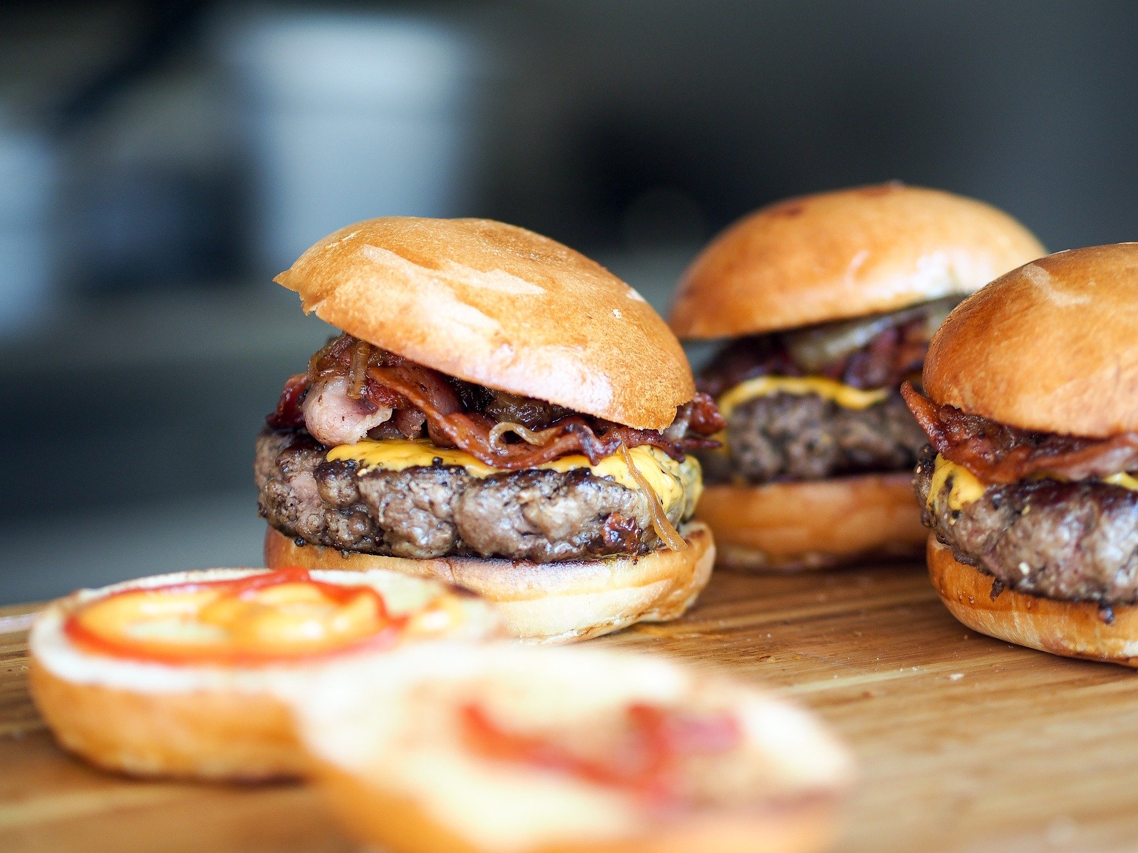

**Ingredients**

**for the burger patties**

* 1 onion finely chopped
* 1 garlic clove crushed
* 500 g beef mince
* large handful fresh parsley finely chopped
* 1/2 cup fresh breadcrumbs
* 1 egg beaten
* 1-2 teaspoons salt to taste
* black pepper to taste

**for the cheeseburgers**

* 4 slices American/Processed cheese
* 8 slices bacon cooked to your preference
* fresh lettuce
* ripe tomatoes sliced
* 4 tsp mayonnaise
* 4 butter-toasted bread rolls

**Instructions**

* Fry the onion in a large frying pan in a splash of olive oil until golden brown. Add the garlic and fry for another 30 seconds then remove from the heat. Allow to cool to room temperature.
* Mix the cooled onions with the beef, parsley, breadcrumbs, egg, salt and pepper. To test the seasoning, fry a teaspoon-full of the mixture in the pan you cooked the onions in. Adjust the seasoning to taste.
* Divide the mixture into 5-6 (depending on how you big you want the patties), and form patties with wet hands.
* Place on a tray lined with baking paper and place in the fridge to chill for 30 minutes.
* When the patties have rested, heat a large cast iron pan/griddle pan until hot then cook the burgers until charred and cooked to your preference. (You can also cook the burgers on a braai/barbecue.)
* Remove from the heat, top with the cheese and cover with foil for 2 minutes.
* Top the buns with a generous spoonful of mayo, lettuce, tomato, the patty with cheese and finally bacon.
* Serve immediately.

**Greek salad**

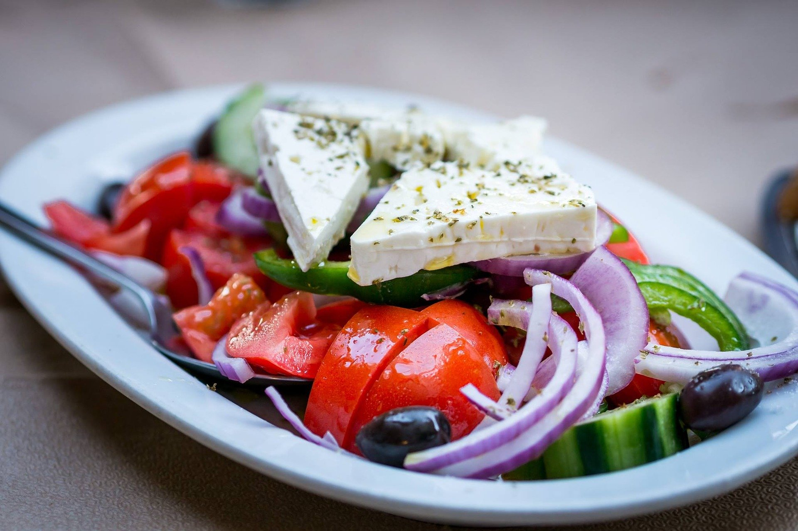

Ingredients

* 1 medium cucumber
* 1 large tomato
* 3 radishes
* 1 small onion, yellow or red
* 1/2 bell pepper
* 3/4 cup feta cheese cubes
* 1/2 cup whole pitted black olives
* 4 tablespoons extra virgin olive oil
* 3 tablespoons lemon juice
* 1 clove garlic, pressed or finely minced
* 1/2 teaspoon dried leaf oregano or about 1 1/2 teaspoons fresh oregano leaves
* 1 head of romaine lettuce, washed, dried, chopped
* Kosher salt and freshly ground black pepper, to taste

Steps to Make It

1. Peel the cucumber if the peel is thick. Slice it into thin rounds. Cut out the stem and core of the tomato and chop. Thinly slice the radishes and onion. Slice the bell pepper into strips.
2. Combine the cucumber and tomato with the sliced radishes and onion. Add the feta cheese and olives.
3. In a small bowl combine the olive oil, lemon juice, garlic, and oregano. Shake or whisk to blend.
4. Toss the vegetables with the lemon and olive oil mixture.
5. Line individual salad bowls or plates with chopped lettuce and top with the salad mixture. Sprinkle lightly with kosher salt and freshly ground black pepper.

**Veal steak**

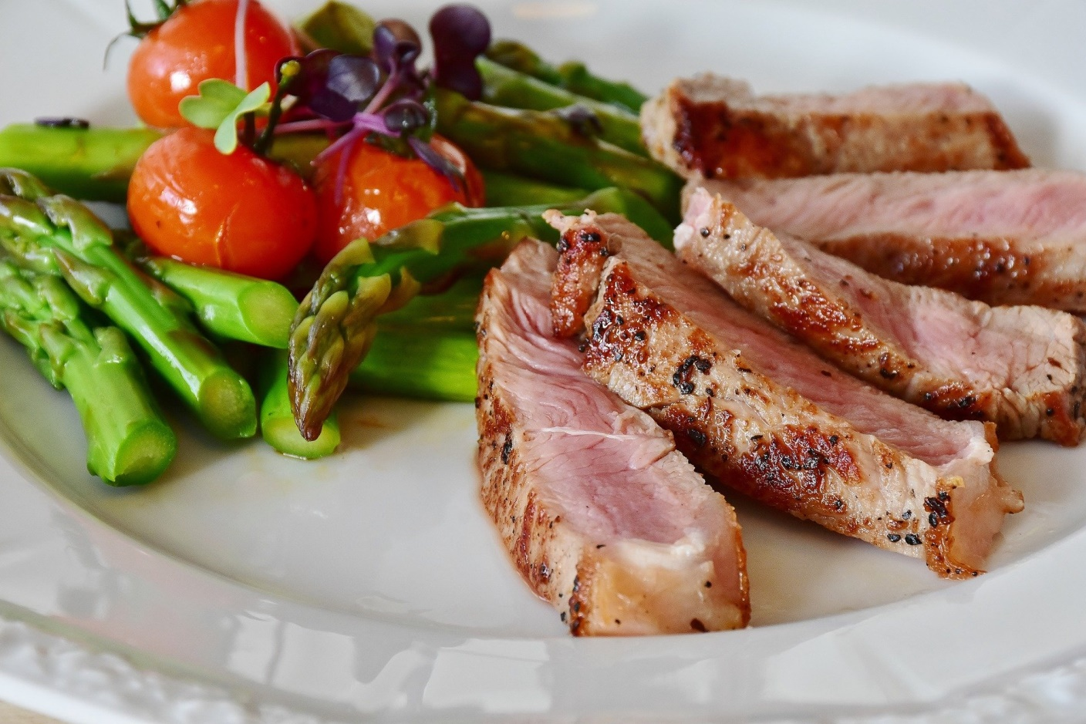

Ingredients

* Four 6-ounce boneless veal loin steaks, about 1 1/4 inches thick
* 2 teaspoons extra-virgin olive oil
* 2 large pinches herbes de Provence or dried thyme
* Salt and freshly ground pepper

1. Preheat the oven to 375°. Heat a large cast-iron skillet over moderately high heat. Rub the veal with the oil and sprinkle with the herbes de Provence and salt and pepper. Add the veal to the skillet and cook, turning once, until well browned, about 1 1/2 minutes per side. Transfer the skillet to the oven and roast for about 8 minutes for medium. Transfer the meat to a plate and keep warm.

2. Add 1/3 cup of water to the skillet and bring to a boil over moderate heat, scraping up any browned bits. Add any exuded juices from the veal and boil until slightly reduced, about 1 minute.

3. Just before serving, transfer the veal to individual plates and spoon the pan sauce on top.

**Cheesecake with lemon**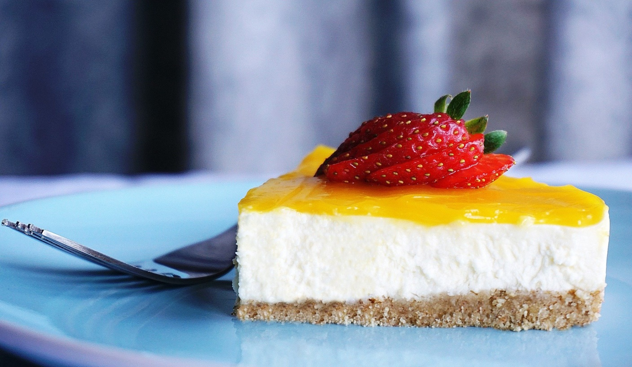

INGREDIENTS

CRUST

2 ¼ cups (302g) vanilla wafer crumbs

½ cup (112g) salted butter, melted

3 tbsp (39g) sugar

CHEESECAKE

24 ounces (678g) cream cheese, room temperature

1 cup (207g) sugar

3 tbsp (24g) all purpose flour

1 cup (240ml) sour cream

3 tbsp (45ml) lemon juice

1 tbsp lemon zest

4 large eggs, room temperature

LEMON CURD

6 tbsp (90ml) lemon juice

1 tbsp grated lemon zest

2/3 cup (138g) sugar

6 large egg yolks

5 tbsp (65g) salted butter

WHIPPED CREAM

3/4 cup (180ml) heavy whipping cream, cold

6 tbsp (43g) powdered sugar

1/2 tsp vanilla extract

INSTRUCTIONS

CRUST

1. Preheat oven to 325°F (163°C). Line a 9-inch springform pan with parchment paper in the bottom and grease the sides.

2. Mix together the crust ingredients until well combined and press the mixture into the bottom and up the sides of the springform pan.

3. Bake the crust for 10 minutes, then set aside to cool.

4. Cover the outsides of the pan with aluminum foil to prepare it for a water bath. Here is a tutorial on how I set up a pan for a waterbath. Set prepared pan aside.

FILLING

1. Reduce oven temperature to 300°F (148°C).

2. In a large bowl, beat the cream cheese, sugar and flour on low speed until well combined and smooth. Be sure to use low speed to reduce the amount of air added to the batter, which can cause cracks. Scrape down the sides of the bowl.

3. Add the sour cream, lemon juice and lemon zest and mix on low speed until well combined.

4. Add eggs one at a time, mixing slowly to combine. Scrape down the sides of the bowl as needed to make sure everything is well combined.

5. Pour the cheesecake batter into the crust and spread evenly.

6. Place the springform pan inside another larger pan. Fill the outside pan with enough warm water to go about halfway up the sides of the springform pan. The water should not go above the top edge of the aluminum foil on the springform pan.

7. Bake the cheesecake for 65 minutes.

8. Turn off the oven and leave the cheesecake in oven with the door closed for 15 minutes. Do not open the door or you’ll release the heat.

9. Crack oven door and leave the cheesecake in the oven for another 20 minutes. This cooling process helps the cheesecake cool slowly to prevent cracks.

10. Remove from oven and let sit on the counter for 15 minutes, then remove the pan from the water bath and remove aluminum foil. Refrigerate cheesecake until completely cooled and firm, 6-7 hours.

LEMON CURD

1. While cheesecake cools, make the lemon curd. Combine all ingredients in a double boiler, or in a metal bowl over a pot of simmering water. Do not boil the water or the heat will be too hot. Occasionally lift the bowl off the pot to release the steam.

2. Heat while whisking constantly until mixture thickens and reaches 160°F (71°C). Refrigerate until cool and thickened.

TO FINISH OFF THE CHEESECAKE

1. When the cheesecake is cool and firm, remove from the springform pan and set on a serving plate.

2. To make the whipped cream, add heavy whipping cream, powdered sugar and vanilla extract to a mixing bowl fitted with the whisk attachment and whip until stiff peaks form.

3. Pipe swirls of whipped cream around the edge of the cheesecake.

4. Spread the lemon curd in an even layer on top of the cheesecake.

5. Refrigerate cheesecake until ready to serve. Cheesecake is best for 2-3 days.

PASTA PUTTANESCA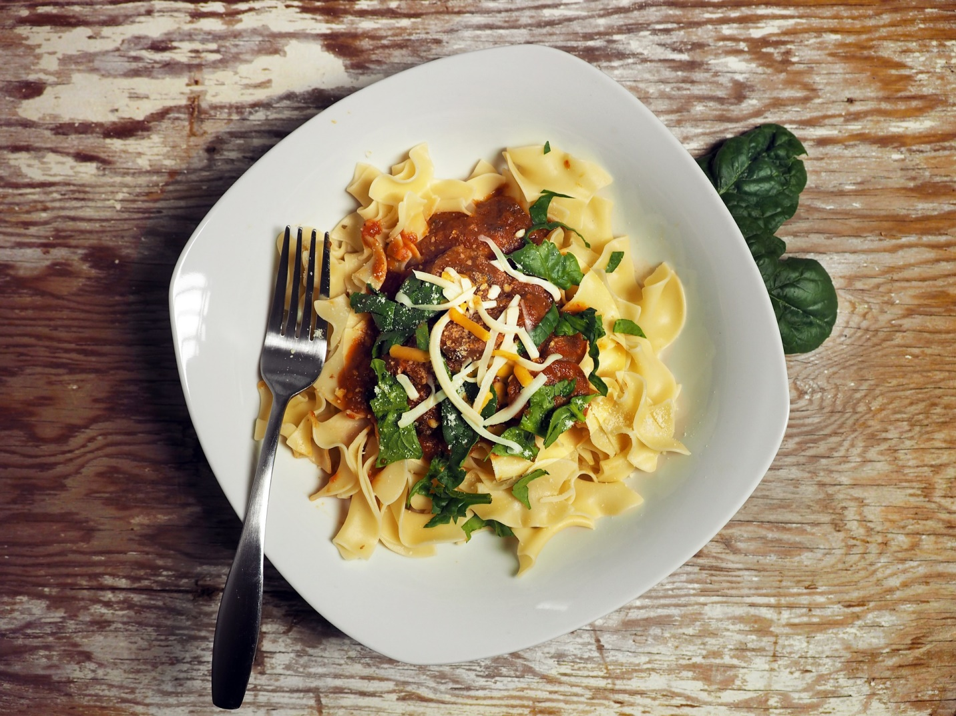

**INGREDIENTS**

* 2 tablespoons extra virgin olive oil
* 1/2 cup finely chopped onion
* 3 cloves garlic, finely chopped
* 3-4 canned anchovies, chopped
* 2 tablespoons tomato paste
* 1/2 teaspoon red pepper flakes
* 1 (28-ounce) can crushed tomatoes
* 2 teaspoons dried oregano
* 2 tablespoons small (non-pariel) capers
* 3/4 cup (95 g) pitted olives (black or green), roughly chopped
* 1 pound spaghetti, linguine, or fettuccine
* Salt
* Extra virgin olive oil for drizzling
* 1/4 cup chopped fresh parsley

**METHODHIDE PHOTOS**

**1 Heat pasta water:** Bring a large pot of salted water to a boil (1 Tbsp of salt for every 2 quarts of water). While the water is heating, start making the sauce.

**2 Cook onions, anchovies, garlic:** Heat the olive oil over medium heat in a large, deep sauté pan. When the oil is hot, cook the onions until they're soft and translucent, about 4-5 minutes.

While the onions are cooking, stir in the chopped anchovies along with some of the oil from the can.

Add the finely chopped garlic and cook another minute.

**3 Make the sauce:**Mix in the tomato paste and cook it for 2 minutes, stirring occasionally. Add the crushed tomatoes, oregano, chili pepper flakes, olives, and capers. Bring the sauce to a simmer, then lower the heat to low to maintain a gentle simmer, 10 to 15 minutes.

**4 Cook the pasta:** When the salted pasta water is at a rolling boil, add the pasta. Cook the pasta according to the package instructions, to al dente, cooked but still slightly firm.

**5 Finish the sauce:**Stir the parsley into the pasta sauce. Add some pasta water into the sauce to thin it if it has become too thick.

**6 Serve:**Drain the pasta and put in a large bowl. If you want, mix a little olive oil into the pasta so the pasta doesn't stick together.

Add a ladle's worth of sauce to the pasta and mix to combine. Serve in shallow bowls with more sauce on top.

# Chipotle Pumpkin Soup

### 

### INGREDIENTS

* 2 tablespoons extra virgin olive oil
* 1 medium yellow onion, chopped
* 3 garlic cloves, chopped
* 1 teaspoon ground cumin
* 1-2 chipotle peppers (canned in adobo, 1 for mild, 2 for spicy), chopped
* 8 cups chopped, cooked pumpkin* (1 7-8 pound cooking pumpkin to yield 8 cups cooked pumpkin, or 3 15-ounce cans of canned pureed pumpkin)
* 4 to 6 cups chicken stock, depending on desired thickness and how thick your pumpkin purée is (use vegetable stock for vegetarian or vegan option, can sub water for some of the stock)
* 1 teaspoon dried oregano or 1/2 teaspoon ground oregano
* 2 teaspoons salt, more to taste
* 2 tablespoons lime juice

Garnishes:

* Toasted, shelled pumpkin seeds
* Cilantro
* Creme fresca, creme fraiche or sour cream thinned with a little water so that it's runny

**1 Sauté onions, garlic, cumin, chipotle:** Heat oil in a large pot (8-quart) on medium high heat. Add the onions and cook for 3-4 minutes, until softened. Add the garlic, cumin, and chipotle, cook for 1 minute more.

**2 Add pumpkin, stock, oregano, salt, then simmer:** Add the pumpkin, chicken stock, oregano, and salt. Bring to a simmer, reduce the heat and simmer for 20 minutes, partially covered.

**3 Toast pumpkin seeds:** If you are working with raw pumpkin seeds, now would be a good time to toast them. (If your pumpkin seeds are already toasted, skip this step.) Just spread them out in an even layer in a frying pan on medium high heat. Stir with a wooden spoon while toasting, until the pumpkin seeds are fragrant and are lightly browned. Remove to a bowl.

**4 Purée soup:** Remove the soup from heat. Working in batches of 2 cups each, purée the soup in batches, holding down the lid the your blender tightly while puréeing, and starting on a slow speed. Return the puréed soup to the pot.

**5 Add lime juice and more seasonings:** Add lime juice. Adjust seasonings to taste, adding more salt, cumin, oregano, or chipotle to taste. If the soup is too thick, add more stock or water to desired consistency.

Serve with toasted pumpkin seeds (pepitas), crema fresca drizzled over the top, and chopped cilantro.

# Mint and Lime Mojito

### 

### INGREDIENTS

* 10 large mint leaves, plus extra for garnish
* 1 tablespoon sugar
* 2 1/2 ounces white rum
* 1 tablespoon lime juice (from half a lime)
* Soda water
* A few sprigs fresh mint, to garnish
* Thinly sliced wheels of lime, to garnish
* **1 Make the mint paste:**Place the mint, sugar, and 1/2 ounce of the rum into the bottom of a mortar and pestle, and grind slowly until it turns into a paste.
* **2 Add the rest of the rum and allow it to steep for about 5 minutes.** If your mortar is too small for the additional rum, transfer the paste to a small bowl and then add the rum.
* **3 Strain the rum.**Fill a glass with ice. Set a small mesh strainer over the glass and strain the mint mixture. Use a spoon to press out every last drop of rum from the paste. (Use a large bowl and strainer if that’s all you have then transfer to the glass. Whatever works for you.)
* **4 Finish the cocktail.**Add the lime juice and top with soda water. Stir together and garnish with a lime wheel or a sprig of mint if you’re feeling extra fancy.